# RESIDUAL SURVIVAL AND LOCAL DISPERSAL DRIVE REINFESTATION FOLLOWING INSECTICIDE SPRAYING BY *TRIATOMA DIMIDIATA* IN GUATEMALA

**Sara Helms Cahan1\*, Lucia C. Orantes2, Kimberly Wallin2, John Hanley3, Donna M. Rizzo3, Lori Stevens1, Patricia Dorn4, Antonieta Rodas5, Carlota Monroy5**

1Department of Biology, University of Vermont, Burlington, Vermont, USA

2Rubenstein School of Environment and Natural Resources, University of Vermont, Burlington, Vermont, USA

3Department of Civil and Environmental Engineering, University of Vermont, Burlington, Vermont, USA

4 Department of Biological Sciences, Loyola University New Orleans, New Orleans, Louisiana, USA

5 Laboratory of Applied Entomology and Parasitology, San Carlos University, Guatemala. C.A.

\*Corresponding author

E-mail: scahan@uvm.edu

Running Title: Post-spray reinfestation and dispersal of *Triatoma dimidiata* in Guatemala

Keywords: vector-borne disease, Chagas disease, insecticide control, house infestation, Ecohealth, kinship, spatial autocorrelation, population genetics.

## Introductory Paragraph

Understanding vector movement is critical to disease ecology. Chagas disease is caused by the protozoan parasite *Trypanosoma cruzi* and transmitted by triatomine insect vectors. Household insecticide spraying is only temporarily effective, and identifying sources of re-infestation has been hampered by a lack of high-resolution markers to track movement patterns. Here, we show that re-infestation by *Triatoma dimidiata* following spraying in rural Guatemala results from a combination of incomplete elimination and local dispersal. We analyzed re-infestation patterns in two villages; houses in the first were surveyed, treated, then re-surveyed after eight and 22 months; the other served as an untreated control. Insects were genotyped at 2-3,000 SNP loci, revealing within- and among-household relatedness patterns. Insecticide application reduced infestation and abundance; nevertheless, within two years 35.5% of treated houses were re-infested. Both residual survival and localized dispersal were found to be important drivers of re-infestation: insects collected post-spraying were most closely related to pre-spray collections from the same house, and both within-house kinship distributions and village-wide spatial genetic structure were consistent with a pulse of immigration from neighboring houses during the dry season. Given these patterns, making houses refractory to vector colonization is likely to be critical for long-term reduction of *T. cruzi* transmission risk.

## Introduction

The dynamics of vector-borne diseases are strongly impacted by the ecology and evolutionary potential of vectors across time and space, from regional diversification to local patterns of movement. Chagas disease, caused by the parasite *Trypanosoma cruzi*, is transmitted by insects of the Triatominae subfamily. Distributed from southern USA to northern Argentina; approximately 6 million people in Latin America are infected and 60 million live at risk (WHO 2015).

In Central America, the main Chagas vector is the native *Triatoma dimidiata* (Dorn et al. 2007). Historically, residual insecticides were recommended to reduce disease transmission due to ineffective therapeutics and the lack of a vaccine (Hotez et al., 2008). Although successful for some, especially introduced, vector species (Hashimoto and Schofield 2012), ecological differences make simply spraying insecticide ineffective against native vectors (Hashimoto et al. 2006, Bustamante et al. 2009, Weeks et al. 2013, Dorn et al., 2018a,b,). Insecticide effectiveness declines in 3-6 months and peridomestic and sylvan populations can rapidly reinfest houses (Barbu et al. 2014, Bustamante et al. 2009, Taburu et al. 1998). An alternative, evidence-based Ecohealth approach, including reducing infestation through house improvements was developed and is gaining acceptance (Zeledón and Rojas 2006, Monroy et al. 2009, Monroy et al. 2012, Lucero et al. 2013, Gürtler and Yadon 2015, De Urioste-Stone et al. 2015, Yoshioka et al. 2015, Zamora et al. 2015, Dorn et al. 2018b).

Evidence-based vector control strategies require understanding mechanism(s) of population recovery after insecticide application, including residual survival and reinfestation. Eggs can survive insecticide, and early *T. dimidiata* nymphal stages can avoid insecticides by fitting deep into crevices and needing few blood meals (Zeledón et al., 1970a). High mobility from untreated houses, which may serve as "hotspots" for recolonization (Cecere et al. 2004, Stevens et al. 2015), peridomestic and sylvan foci facilitate reinfestation. In particular localities, rapid re-colonization from peridomestic ecotopes is associated with an annual dispersal peak at the end of the dry season (March – May, ). Reinfestation may also involve migration or passive transport from sylvan areas or neighboring villages (Dorn et al. 2003, Monroy et al. 2003, Ramirez-Sierra et al. 2010, Barbu et al 2011, 2014, Gourbière et al. 2012, Lucero et al., 2013, Bustamante et al. 2014, Stevens et al. 2015). Thus, understanding the timing, origins and distance of vector movement, both in the presence and absence of insecticide,is critical for effective long-term management of transmission risk.

In this study, we examined the ecology and evolution of Chagas vectors through fine-scale genetic analysis evaluating the relative contributions of within-house persistence, immigration and local dispersal to *T. dimidiata* infestation in the department of Jutiapa, Guatemala. We assessed infestation rates and patterns of spatial genetic structure at multiple time points in two villages (Supplementary Fig. S1), one treated with insecticide during the survey period. Survey data combined with vector kinship and population-genetic analysis using 2-3,000 genome-wide single nucleotide polymorphic markers (SNPs) from a genotyping-by-sequencing (GBS) pipeline evaluated: (1) the effectiveness of insecticide application in reducing abundance and genetic diversity (2) population “reinfestation” from survival of insecticide and/or re-infestation by dispersers, and (3) the spatial scale of seasonal dispersal.

## Results

**Household *T. dimidiata* infestations are multigenerational, extended families**

To characterize the baseline infestation and population structure of *T. dimidiata*, both villages were exhaustively surveyed in the absence of spraying and prior to the dry season when dispersal is expected to be highest. Infestation surveys revealed similar initial patterns in the two villages. Approximately 20-25% of surveyed houses were found to be infested (24.0%, 31 of 129 houses in El Carrizal; 21.6%, 30 of 139 houses in El Chaperno), with a mean of 7.73 ± 2.04SE and 7.51 ± 2.45SE insects collected per infested house, respectively. The majority of *T. dimidiata* collected were non-flying nymphal stages (El Carrizal: 73.8%; El Chaperno: 71.6% nymphs). In both villages, patterns of genetic relatedness were strongly structured at the house level. Genetic kinship was significantly higher for *T. dimidiata* collected from the same house than those collected from different houses (Kolmogorov-Smirnov two-sample tests, all p < 0.0001; Fig. 1A, B, Fig. 2A, B). In El Carrizal, within-house kinship followed a unimodal distribution consistent with an extended family (median k=0.104). Household infestations in El Chaperno were similarly related (median k=0.093), with a multi-modal distribution that included distant (k=0.04), close (k=0.17), and parent/sibling (k=0.5) kinship peaks. The genetic distinctiveness of individual houses matches other results in Guatemala using microsatellite markers (Stevens et al. 2015), and suggests that previous work indicating panmixia among houses and villages may have been hampered by low marker resolution (e.g., Dorn et al. 2003). Although most co-habiting insects were related, sibling/parental kinship values (k~0.5) were extremely rare (<1%), supporting the conclusion by Melgar et al. (2007) that infestations are derived from multiple unrelated founders, either during initial colonization or from subsequent immigration.

**Effects of spraying on infestation and genetic diversity were incomplete and temporary**

To determine the efficacy and duration of insecticide spraying on *T. dimidiata*, the village of El Carrizal was resurveyed at eight and 22 months following insecticide spraying of all infested houses. The infestation indexdeclined significantly to 12.4% in the 8-month post-spray survey (16 houses, X21 =5.72, p < 0.016), and remained significantly lower at the 22-month post-spray survey (17 houses, 13.2%; X21=7.29, p < 0.006). In total, 25 houses were found to contain *T. dimidiata* at one or both of the post-spray surveys, including 11 (35.5%) of the houses initially treated for infestation and 14 new infestations. For the subset of houses infested prior to spraying, per-house abundance was significantly lower post-spray than pre-spray at both eight and 22 months following spraying, dropping from 7.73 ± 2.04 insects per house to 1.42 ± 0.79 after eight months and 2.58 ± 0.99 at 22 months after spraying (mixed-model GLM, main effect of time point, F2,50 = 7.36, P < 0.01; pre-spray vs. 8-months post-spray, P < 0.01, pre-spray vs. 22-months post-spray, P < 0.05). Nymphs made up an average of 65-78% of the insects collected per house, with no significant difference in demographic composition across surveys (F2,61 = 0.78, P = 0.46) (Supplementary Fig. S2).

In contrast, in the absence of spraying neither infestation index nor per-house abundance in the village of El Chaperno changed between surveys. There were 30 infested houses in 2012 and 32 in 2013 (21.3% of the houses surveyed), of which 17 houses were recurrently infested in both surveys. No spatial clustering of infested houses was detected at either sampling time point (Supplementary Fig. S3).

Although when taken together, survey period had a marginally non-significant effect on per-locus allelic diversity (Pi) in El Carrizal (ANOVA, F2,3489=2.90, p=0.055). Pairwise comparisons revealed a significant decrease in Pi from the pre-spray survey to the 8-month post-spray survey (Tukeys HSD test, P < 0.05), which recovered to an intermediate value by the 22-month post-spray survey and that did not differ significantly from either the pre-spray or 8-month post-spray (Table 2). Population samples for both villages showed very low though statistically significant genetic differentiation over time (FST ~ 0.005), with the exception of the 8-month and 22-month post-spray periods in El Carrizal, for which differentiation nearly doubled (FST = 0.0085; Table 2). These results are similar to previous studies (Dorn et al. 2003, Ramirez-Sierra et al. 2010, Stevens et al. 2015) showing systematically high genetic diversity in *T. dimidiata* despite periodic spraying campaigns both within villages and across the region since 2000. The population inbreeding coefficient (FIS) decreased from 0.29 to 0.15 from the pre-spray to the 8-month post-spray survey, increasing to 0.20 by the 22-month post-spray survey (Table 2). FIS in untreated El Chaperno was similar to the pre-spray value for El Carrizal both prior to and following the dispersal season (Table 2).

**Both residual survival and local movement contributed to re-infestation**

To determine the source(s) of house re-infestation, we first evaluated whether insects from re-infestated houses represented a random sample of the pre-spray population, as expected if household infestations were fully eliminated and then repopulated by immigrants without regard to spatial origin. The hypothesis of panmictic replacement was not supported: 47.2% of post-spray *T. dimidiata* were most closely related to a pre-spray *T. dimidiata* from the same house, significantly more likely than that expected by chance (randomization test, P < 0.001, threshold cutoff = 19.4%). These findings are consistent with direct observation that a single insecticide treatment eliminates <20% of domiciliated insects in a house, leaving a large pool of potential survivors to repopulate the house (Monroy et al. 1998b). Houses whose construction makes them susceptible to *T. dimidiata* infestation are characterized by the presence of physical refuges where insects can hide and possibly escape insecticide contact, including absent or cracked wall plaster, unfinished floors and roofs (Bustamante et al. 2009, 2014, Sol Gaspe et al. 2015). Eggs are also known to be resistant to insecticide (Zeledón et al., 1970a), and evolved resistance to pesticides has been reported in related triatomines as a result of sustained eradication programs (Mougabure-Cueto & Picollo 2015), although resistance has not yet been documented in *T. dimidiata.* Moreover, insects may enter vacant niches post-spray from the immediate peridomestic environment. Peridomestic refuges, including domestic animal enclosures, wood piles, stone walls, and other structures with abundant crevices, can serve as significant insect reservoirs, and blood feeding patterns are suggestive of high levels of movement between the house interior and peridomestic spaces in both *T. dimidiata* and *T. infestans* (Bustamante et al. 2014, De Urieste-Stone et al. 2015, Guertler & Yadon 2015, Provecho et al. 2017).

When *T. dimidiata* were most closely related to a pre-spray insect from a different house, the mean distance between houses was significantly shorter than that expected if dispersal had occurred at random, suggesting that post-spray immigration resulted from localized movement (randomization test, P < 0.001; Supplementary Fig. S4). The spatial pattern of infestation also suggested dispersal from neighboring houses; although no spatial clustering of infested houses was found in the pre-spray survey, significant clustering was observed among infested houses eight months after the insecticide application, mostly driven by the presence of nymphs, which are known to disperse on foot between houses (Monroy et al. 2003) (R= 0.831, z=-4.29, p=0.019). The 22-month post-spray survey also showed significant clustering among infested houses, driven by the presence of nymphs (R= 0.644, z=-10.13, p<0.001) and males (R=0.813, z=-6.91, p<0.018).

Both within-household and population-level genetic analyses in treated El Carrizal were also consistent with a combination of incomplete elimination and within-village local dispersal following spraying. Kinship distributions shifted significantly following spraying (Kolmogorov-Smirnov test, D= 0.121, p<0.005); unlike the unimodal distribution prior to spraying, the 8-month post-spray households were dominated by a mode of unrelated individuals (k=0) in addition to density peaks for distantly related (k=0.08) and more closely-related individuals (k=0.18) (Fig 1B). The 22-month post-spray distribution returned to unimodal (median k=0.082) and did not differ significantly from either the pre-spray or the 8-month post-spray distribution (Fig. 1C).

Spatial analysis of population genetic structure across the village from all three surveys (N=245) recovered four genetically distinct clusters, all of which were present in the pre-spray collection (Fig 3A insert). Cluster representation within the population changed significantly across sampling periods (G-test of heterogeneity, G6 = 21.5, P < 0.01), driven by a shift between the pre-spray and 8-month post-spray *T. dimidiata* (G6 = 15.8, P < 0.02). Cluster 1 dropped from 18% of the population in the pre-spray survey to only 3% in the 8-month post-spray survey, and cluster 4, the rarest initially, was not detected in the 8-month post-spray population (Fig. 3A). Yet all four were found in the final post-spray sampling, and the composition of the population had returned to proportions not different from the pre-spray survey (G6 = 4.4, P = 0.62). As with spatial patterns of infestation, houses were positively spatially autocorrelated in cluster membership in both the pre-spray and 22-month post-spray surveys up to a range of 362 meters, suggesting local exchange of migrants (Fig 3B). No consistent pattern of spatial autocorrelation was detected in the 8-month post-spray survey, although the small number of infested houses reduced the power of the test for most distance classes (n=1-16 comparisons per distance class; Fig 3B).

Dispersal in the absence of spraying did not alter overall population-genetic parameters in untreated El Chaperno (Table 2), but within-village movement associated with the dispersal season similar to that observed in treated El Carrizal was detected. Kinship distributions within houses shifted significantly in El Chaperno following the March-May dispersal season (D= 0.209, p=0.0017), from a multi-modal distribution of kinship values to a right-skewed distribution in the post-dispersal survey (median k=0.061) predominantly driven by a peak of distant kinship (k=0.04) but lacking the higher-relatedness modes from prior to the dispersal season (Fig. 2B). The El Chaperno population, including both pre- and post-dispersal season *T. dimidiata*, was separated into two genetically distinct clusters, each containing roughly similar proportions of individuals at each sampling point (prior to dispersal: 0.39:0.61; following dispersal: 0.53:0.47) (Fig. 4A). Prior to dispersal, spatial autocorrelation of house cluster membership was limited to short and relatively long distances (38m, 370-390m; Fig. 4B); following the dispersal season, however, genetic cluster membership was positively autocorrelated up to a range of 150m.

The flow of dispersers appeared to be driven by local movement from high-infestation houses. This was most clearly seen in El Chaperno, where a single house (D-54) initially contained 21% of all *T. dimidiata* forming genetic cluster 1 and was relatively distinct from nearby houses in cluster membership, but following dispersal both overall infestation incidence and cluster 1 membership increased in the area immediately surrounding this house (Fig. 4A). This conclusion is congruent with previous findings that show *T. dimidiata* to be a relatively poor flier that depends on terrestrial movement or passive transportation, implying that dispersal is most likely at short distances (Dumonteil et al. 2004, Monroy et al. 2003). Low density of potential source houses post-spraying may explain the relatively larger spatial scale of autocorrelation in El Carrizal, as dispersers are likely to encounter few competitors for vacant niches even at higher distances from their natal source. Local dispersal may be a typical feature of Chagas vectors, as proximity to nearest infested house also significantly predicted infestation by *T. infestans* in Gran Chaco, Argentina (Sol Gaspe et al. 2015).

## Discussion

Targeted insecticide treatment is an economically attractive method for controlling Chagas disease vectors in Central America, yet its effectiveness can be short-lived. Whether this is the result of insecticide ineffectiveness, shifting of insects from infested to uninfested houses, or influx from the surrounding sylvan environment has been challenging to determine due to poor resolution from morphological and molecular markers used in the past to distinguish sources of origin of re-infesting insects (e.g., morphometry, Hernandez et al. 2013; mtDNA sequence variation, Quisberth et al. 2011; microsatellites, Stevens et al. 2015). Although SNP loci are individually low in variability, by including information from thousands of loci encompassing a range of minor allele frequencies, the SNP markers derived from GBS sequencing used in this study were successful at resolving kinship patterns at the household, local, and village scale, allowing a greater precision of source assignment than was possible previously. The results of this study suggest two main reasons for population recovery of the vector *T. dimidiata* in Guatemalan villages. First, targeted spraying is ineffective at completely eliminating infestations, resulting in endemic recovery as survivors reproduce and repopulate available domestic niches. Second, houses with surviving insects, whether due to initial non-detection (Monroy et al. 1998a) or survival of insecticide treatment, can serve as a local reservoir for re-infestation of nearby houses. Sylvan influx appears to be a less important mechanism of re-infestation than within-village processes, which is consistent with the high level of deforestation in this region of Guatemala.

Our findings address one of the most limiting characteristics of chemical control: the inability to prevent population recovery after the residual effect of the insecticide has subsided. In Jutiapa, Guatemala, we observed that *T.dimidiata* populations suffer little reduction in population genetic diversity, and disperse frequently to neighboring houses through seasonal dispersal activities. It is important to note, however, that the absence of insecticide-mediated changes at these markers does not preclude possible evolutionary shifts at loci influencing insecticide resistance; more comprehensive or gene-enriched SNP genotyping would be required to identify specific genomic regions responsive to insecticide-mediated selection. In combination with resident insect survival, under the right biological conditions (e.g. frequent blood meals) *T. dimidiata* can repopulate a house in only a few generations. Although an intensive, frequently scheduled insecticide program, such as that used to eradicate *R. prolixus* from Central America (Hashimoto and Schofield 2012), could potentially permanently eliminate *T. dimidiata*, sporadic insecticide application is easily overcome by the ability of the residual population to breed and disperse as long as sufficient habitat remains available in the domestic environment. Multiple studies have shown that implementating eco-health strategies that include low-cost house improvements and integrated pest management can increase the long-term effectiveness of control by interrupting the process of house colonization (Gürtler and Yadon 2015, De Urioste-Stone et al. 2015, Lucero et al. 2013, Monroy et al. 2009, Yoshioka et al. 2015, Zamora et al. 2015, Zeledón and Rojas 2006).

Previous studies have addressed the importance of preventing dispersal from peridomestic and sylvan sources after insecticide applications; however, the improved spatial resolution made possible by high-throughput SNP genotyping technologies has significantly improved our ability to identify small-scale patterns and dispersal dynamics over time. This study is the first to show that insecticide survival and dispersal among neighboring households are crucial factors facilitating recovery of the vector in human households. Explicit consideration of the role of highly-infested houses and unimproved structures as reservoirs should lead to improved management and control of the vector in these highly vulnerable communities.

## Methods

**Study sites and entomological surveys**. To examine patterns of dispersal and spray recovery, two villages in the Department of Jutiapa, Guatemala were surveyed for vector infestation and abundance over time; in one village surveys encompassed a spraying event (El Carrizal), while in the second, surveys spanned the annual dispersal season in the absence of spraying (El Chaperno). Both El Carrizal (14.3766, -89.9863, 700 mamsl) and El Chaperno (14.3491, -89.9468, 700 mamsl) are rural communities in the dry highlands, divided by a mountain range crossing North to South (Fig 1). The National Institute for Seismology, Volcanology, Meteorology and Hydrology in Guatemala reports an average annual precipitation for Jutiapa of 1,633 mm concentrated in the months of May through October, and peaking in the month of September (INSIVUMEH meteorological database, 2012;  <http://www.insivumeh.gob.gt/>). The Euclidean distance between village centers is 5.26 km, with an effective road distance of 11.6 km. In both villages, most houses are built with adobe and other local materials, with fewer than 10% built from cement blocks. The vector control program in both villages was based solely on insecticide applications of deltamethrin, a third generation pyrethroid; the Ministry of Health reported the most recent insecticide campaigns were three years prior to the study period for El Carrizal and four years prior for El Chaperno.

In El Carrizal, a pre-spray survey was conducted in February 2013 and all infested houses with one or more *T. dimidiata* were treated with deltamethrin between the months of March and May 2013, according to the Guatemalan Department of Health Vector Control Protocol (Jutiapa, Guatemala) (Table 1). Eight months after spray completion (Jan. 2014), the first of two post-spray surveys was coordinated to collect specimens and assess differences in abundance after the insecticide treatment. Houses were not treated at this time. Twenty-two months after spraying (April 2015), a second post-spray survey was conducted (Table 1). In El Chaperno, houses were surveyed in the first week of Oct. 2012 at the end of the rainy season and prior to the putative annual dispersal season. Eight months after the first collection, a post-dispersal season survey was conducted amid the following rainy season on July 2013 (Table 1). In both villages, once the study was completed, the Ministry of Health treated all houses identified as infested from any of the surveys with deltamethrin.

Surveys to search for *T. dimidiata* were conducted as a collaboration with Laboratorio de Entomoligía Aplicada y Parasitología (LENAP) at San Carlos University of Guatemala and the National Vector Control Program implemented by Guatemala’s Ministry of Health (Jutiapa, Guatemala). The person-hour method was used to search for *T. dimidiata* inside houses on walls, floors, in clutter, animal nests and personal belongings (Monroy et al. 1998a). All houses from both villages were geo-referenced (waypoint error = ± 6 m) during the initial surveys using Garmin eTrex® GPSs, set to WGS 84 map datum. The *T. dimidiata* specimens located during each survey were collected live, transferred to vials containing 95% ethanol, stored at room temperature at LENAP and transported within a week to the University of Vermont where they were stored at -20°C until DNA was extracted for sequencing.

**DNA extraction and GBS sequencing.** DNA was extracted from a total of 1045 *T. dimidiata* specimens*,* 624 from El Carrizal and 421 from El Chaperno. Although this included representatives from all infested houses and all collected insects were included if three or fewer insects were recovered from a house, high-infestation houses (over three insects collected) were sub-sampled (range = 3-21 insects/house) to prioritize adults if collected, followed by 4th-5th stage nymphs and lastly 1st-3rd instar stage nymphs. DNA was extracted from either three posterior segments of the insect abdomen and one surface-sterilized leg (including attached muscle) or the thorax. We also extracted the DNA from 12 surface-sterilized leg specimens collected from across the range of *T. dimidiata* to build a DNA reference catalog of 5,177 tags to identify vector sequences separate from contaminating microbes and blood meals as described in Justi et al. (2018). The DNA from the specimens was extracted by flash freezing the tissue in liquid nitrogen, homogenizing it with a bead-based homogenizer and using a modified Qiagen DNeasy™ tissue extraction protocol. Modifications included a 12-hour Proteinase K digestion at 56°C, followed by an RNAse digestion at 37°C for 30 minutes using 1.0uL of 4mg/mL RNAse. DNA was quantified using a Qubit spectrophotometer high-sensitivity protocol, and quality of the molecular weight was determined by electrophoresis on a 1.5% agarose gel stained with Sigma-Aldrich Nancy-520™. Only specimens with a minimum yield of 900 ng of DNA and molecular weight above 600 bp were considered suitable for sequencing; because *T. dimidiata* are blood-feeding and the abdomen can contain significant amounts of degraded blood meals, DNA quality was variable. Of the original 1,045 extracted specimens, a total of 464 were sequenced, which included 121 pre-spray, 69 early post-spray and 68 final post-spray *T. dimidiata* from El Carrizal, and 99 pre-dispersal season and 107 post-dispersal season samples from El Chaperno.

GBS library preparation was conducted using the restriction enzyme *PstI* (6-base cutter: 5′ — CTGCA⬇G — 3′, 3′ — G⬇ACGTC — 5′) at the Cornell Genomic Diversity Facility (Ithaca, NY) following the Genotyping-by-Sequencing (GBS) protocol of Elshire et al. (2011). Each specimen was barcoded, and multiplexed in a 48-plex format on an Illumina HiSeq Analyzer. The raw sequencing reads were 93bp in length, including the inline 5-bp barcode and 6-base*PstI* recognition sequences. We used FastX-trimmer in the FastX-toolkit to remove the barcodes and recognition sites (Gordon & Hannon 2010). The trimmed 82-bp long sequences were filtered using FastQ-quality-filter to remove sequences with any base having a confidence score below 10.

The 464 sequenced specimens were mapped to the reference catalog with Bowtie (Langmead 2010). Genotypes were called using the Stacks *ref\_map* pipeline independently for El Carrizal and El Chaperno to include only loci polymorphic for each village (Catchen et al. 2013). We set the parameters for the reference mapping to a depth of coverage of 3X, allowing three mismatches among tags from the same individual and three mismatches between individuals. We excluded any SNP that was not represented in at least 50% of the individuals and those that violated Mendelian genetics in any individual (i.e., > 2 alternative bases at the SNP). After filtering, the pipeline yielded a total of 2,780 informative SNPs for El Carrizal and 2,263 for El Chaperno.

**Infestation index and vector abundance**

Changes in the proportion of surveyed houses found to be infested (the infestation index, WHO 2002) across time points were evaluated with Chi-Squared tests. To test for temporal reduction in abundance within infested houses due to spraying, differences in the abundance and the proportion of nymphs in the subset of houses identified as positive in the pre-spray survey were evaluated with mixed-model GLMs using the JMP statistics package (ver. 9, SAS Institute Inc., Cary, NC). Survey period was included as a fixed factor, with house ID as a random factor. Similar analysis was conducted for El Chaperno; in this case, because dispersal may lead to an increase in infested houses, all houses with infestations at one or both survey periods were included in the analysis.

To test for spatial clustering of *T. dimidiata* infestation, the locations of all houses were mapped using individual GIS data layers with a UTM zone 16 NAD27 map projection in ArcGIS 10.1 (ESRI Inc., Redlands, CA). For each survey, houses were classified as infested or uninfested and the spatial distribution of infested houses was tested for spatial clustering using the Average Nearest Neighbor function with inverse distance weighting from the spatial statistics toolbox (ArcGIS, ver. 10.0, ESRI Inc.).

**Household *T. dimidiata* Genetic Structure**

For each sampling point, we estimated pairwise kinship values with the Identity by Descent (IBD) kinship coefficient using Maximum Likelihood Estimation (MLE) with the *snpgdsIBDMLE* function in the *SNPrelate* R package (Zheng et al. 2012). The kinship value k is expected to be 0.5 for parent-offspring or full-sib relationships, with a decay toward zero for more extended relatives (e.g., 0.25 for half-sibs, 0.125 for first cousins, etc.) and zero for unrelated individuals. For each village, we calculated density curves of within- and among-house kinship for each survey and tested for differences in kinship patterns within versus among houses within each sampling period, as well as differences in within-house kinship distributions over time, using non-parametric, pairwise Kolmogorov-Smirnov Tests (K-S test, alpha = 0.05) from the R package *rgr* (Garrett 2013).

To identify the sources of post-spray infestations, we tested whether insects from re-infested houses were more likely to have been derived from pre-spray infestations from either a) the same house, or b) a nearby house, than from a random re-infestation source across the village. Because potential source houses varied in insect abundance, and therefore potential dispersers, prior to spraying, we used a randomization test to generate expected colonization patterns under random dispersal given observed variation in initial abundance. Pairwise kinship values were calculated across the entire set of sampling periods; and to calculate observed re-infestation patterns, for each *post-spray* insect collected from a house re-infestation (i.e., that house had also been infested in the pre-spray survey), the *pre-spray* sample to which it was most closely related was identified. If the nearest relative was collected from the same house, it was classified as a residual infestation; if not collected from the same house, the Euclidean distance between the two houses was calculated as an estimate of infestation dispersal distance. The observed proportion of residual infestations and the mean distance to the source house for non-residual colonizations were compared to the distribution of expected values calculated from randomized datasets, in which each post-spray sample was assigned a randomly selected pre-spray sample as its nearest relative. Calculations from randomized assignments were replicated 1,000 times and the observed results compared to the 95%, 99% and 99.9% most extreme values as probability cutoffs. The randomization test was conducted with a custom-designed python script, available in Supplementary information.

**Population Genetic Structure**

To identify changes in overall population genetic diversity and structure in each village over time due to spraying or dispersal activity, the population fixation index (Fst), nucleotide diversity (Pi), inbreeding coefficient (FIS), observed (Hetob) and expected (Hetex) heterozygosity were calculated for each village and sampling period using the *Populations* function from the *Stacks* software (Catchen et al. 2013).

To identify genetic clusters and cluster assignment of the genotyped individuals from each village, we performed k-means clustering analysis and classified the individuals by a discriminant analysis of principal components (DAPC) using the *Adegenet* package for R (Jombart and Ahmed 2011). Insects with less than 5% of the average number of SNPs were excluded from the analysis to prevent biases due to missing data, this amounted to 13 insects from El Carrizal and 11 from El Chaperno. We identified the number of genetic clusters for each village using the k-means cluster algorithm (from the *find.cluster*s function in *Adegenet*) based on the value of k that minimized the Bayesian Information Criterion (BIC) value. For El Carrizal, we set the maximum number of potential principal components (PCs) to 240, retaining a total of 5 clusters based on the cumulative variance explained by the BIC values. One cluster consisted of a single individual (CHJ484), thus we re-ran the analysis excluding this sample. The final DAPC was best explained with 4 clusters and CHJ 484 as an outlier. For El Chaperno, we set the maximum number of potential PCs at 180, retaining a total of 2 clusters, based on the cumulative variance explained by the BIC. The cluster identity for each insect was used to project the cluster distributions for each village and each survey using ArcGIS 10.1 (ESRI Inc., Redlands, CA) (UTM zone 16, datum=WGS84). Changes in cluster proportions over time were tested with and RxC G-test of heterogensity, with post-hoc pairwise comparisons when significant overall effects were detected.

To test for spatial structuring in the distribution of the DAPC genetic clusters, we created a matrix of pairwise Jaccard indices, which measures the overlap in sample cluster membership between two houses, and combined it with the Euclidean distance among houses using the *vegdist* function from the R *Vegan* package (Oksanen et al. 2007). To project the coordinates to meters, we converted the degree coordinates to UTM projections (zone 16, datum=WGS84) using the *coordinates*, *proj4string*, and *spTransform* functions from the linked packages *rgdal* and *sp* in R (Bivandet al. 2014, Pebesma et al. 2012). We tested for spatial autocorrelation with Moran’s I correlograms for each village and survey using the *correlog* function from the *ncf*R package (Hijmans and van Etten 2014). The spatial increments (bin size) were selected as 25 m for El Carrizal and 20 m for El Chaperno using the Freedman-Diaconis rule for bin width using a histogram from the longitude distance matrix generated by the *hist* function in the R *Vegan* package (Oksanen et al. 2007). To assess clustering significance at each bin, we ran a permutations test for 100 repetitions (alpha = 0.05) using the *resamp* parameter from the c*orrelog* function. We determined the appropriate window to observe spatial autocorrelation within each village by using the Ripley’s K function to establish the maximum spatial range among houses using the Spatial Statistics toolbox from ArcGIS 10.1 (ESRI Inc., Redlands, CA). The window was set to 580 meters for El Carrizal and 480 meters for El Chaperno. The 95% confidence interval (CI) was calculated from the Moran’s I response vector using the *boot.one* function from the *boot* R package at 10,000 bootstraps and calculating the Bias Corrected and Accelerated Confidence Interval (BCa) for non-parametric functions with the *boot.ci* function from the *boot* R package (Angelo and Ripley 2016, Davison and Hinkley 1997).

## References

Angelo C, Ripley B. 2016. boot: Bootstrap R (S-Plus) Functions. R package version 1.3-18.

Bargues MD, Klisiowicz DR, Gonzalez-Candelas F, Ramsey JM, Monroy C, Ponce C, Salazar-Schettino PM, Panzera F, Abad-Franch F, Sousa OE, Schofield CJ. 2008. Phylogeography and genetic variation of *Triatoma dimidiata*, the main Chagas disease vector in Central America, and its position within the genus Triatoma. PLoS Negl. Trop. Dis. 7:e233.

Barbu C, Dumonteil E, Gourbière S. 2011. Evaluation of spatially targeted strategies to control non-domiciliated *Triatoma dimidiata* vector of Chagas disease. PLoS Negl. Trop. Dis. 17:e1045.

Barbu C, Dumonteil E, Gourbière S. 2009. Optimization of control strategies for non-domiciliated*Triatomadimidiata*, Chagas disease vector in the Yucatán peninsula, Mexico. PLoS Negl. Trop. Dis. 14:e416.

Barbu CM, Buttenheim AM, Pumahuanca M-LH, Calderón JEQ, Salazar R, Carrión M, et al. 2014. Residual infestation and recolonization during urban Triatoma infestans Bug Control Campaign, Peru. Emerging Infect Dis. 20:2055–63.

Bivand R, Keitt T, Rowlingson B 2014. rgdal: Bindings for the geospatial data abstraction library. R package version 0.8-16.

Bustamante DM, Monroy C, Pineda S, Rodas A, Castro X, Ayala V, Quiñónes J, Moguel B, Trampe R 2009. Risk factors for intradomiciliary infestation by the Chagas disease vector *Triatoma dimidiata* in Jutiapa, Guatemala. Cadernos de Saúde Pública. 25:S83-92.

Bustamante DM, De Urioste-Stone SM, Juárez JG, Pennington PM 2014. Ecological, social and biological risk factors for continued *Trypanosoma cruzi* transmission by *Triatoma dimidiata* in Guatemala. PLoS One. 9:e104599.

Catchen J, Hohenlohe PA, Bassham S, Amores A, Cresko WA 2013. Stacks: an analysis tool set for population genomics. Molecular Ecology. 22:3124-40.

Cecere MC, Vazquez-Prokopec GM, Gürtler RE, Kitron U 2004. Spatio-temporal analysis of reinfestation by Triatome infestans following insecticide spraying ina rural community in northwestern Argentina. Amer. J. Trop. Med. Hygiene 71:803-810.

Cecere MC, Vazquez-Prokopec GM, Ceballos LA, Boragno S, Zárate JE, Kitron U, Gürtler RE 2013. Improved chemical control of Chagas disease vectors in the dry Chaco region. Journal of medical entomology. 50:394-403.

Davison AC, Hinkley DV 1997. Bootstrap methods and their application. Cambridge University press.

De Urioste-Stone SM, Pennington PM, Pellecer E, Aguilar TM, Samayoa G, Perdomo HD, Enríquez H, Juárez JG 2015. Development of a community-based intervention for the control of Chagas disease based on peridomestic animal management: an eco-bio-social perspective. Transactions of The Royal Society of Tropical Medicine and Hygiene. 109:159-67.

Dorn PL, Melgar S, Rouzier V, Gutierrez A, Combe C, Rosales R, Rodas A, Kott S, Salvia D, Monroy CM. The Chagas vector, *Triatomadimidiata* (Hemiptera: Reduviidae), is panmictic within and among adjacent villages in Guatemala. Journal of medical entomology. 2003 Jul;40(4):436-40.

Dorn PL, Monroy C, Curtis A. *Triatomadimidiata* (Latreille, 1811): A review of its diversity across its geographic range and the relationship among populations. Infection, Genetics and Evolution. 2007 Mar 31;7(2):343-52.

Dorn PL, de la Rua NM, Axen H, Smith N, Richards BR, Charabati J, Suarez J, Woods A, Pessoa R, Monroy C, Kilpatrick CW, Stevens L 2016. Hypothesis testing clarifies the systematic of the main Central American Chagas disease vector, *Triatoma dimidiata*, across its geographic range. Infection Genetics and Evolution 44:431-443.

Dorn PL, Monroy C, Stevens L. 2018a. Ecohealth Control of Native Vectors: Genetics and ecology inform reduction of transmission of Chagas disease by *Triatoma dimidiata* in Central America. Annual Review of Entomology

Dorn PL, Monroy C, Stevens L 2018b. Ecohealth Control of Native Vectors: The case of *Triatoma dimidiata* in Central America. Annual Review of Entomology

Dumonteil E, Ruiz-Piña H, Rodriguez-Félix E, Barrera-Pérez M, Ramirez-Sierra MJ, Rabinovich JE, Menu F 2004. Re-infestation of houses by *Triatomadimidiata* after intra-domicile insecticide application in the Yucatan peninsula, Mexico. Memórias do Instituto Oswaldo Cruz. 99:253-6.

Elshire RJ, Glaubitz JC, Sun Q, Poland JA, Kawamoto K, Buckler ES, et al. 2011. A robust, simple genotyping-by-sequencing (GBS) approach for high diversity species. PLoS ONE. 6:e19379.

Garrett RG 2013. The ‘rgr’package for the R Open Source statistical computing and graphics environment-a tool to support geochemical data interpretation. Geochemistry: Exploration, Environment, Analysis. 13:355-78.

Gordon A, Hannon GJ 2010. Fastx-toolkit. FASTQ/A short-reads preprocessing tools (unpublished) http://hannonlab. cshl. edu/fastx\_toolkit.

Gourbière S, Dumonteil E, Rabinovich JE, Minkoue R, Menu F 2008. Demographic and dispersal constraints for domestic infestation by non-domiciliated Chagas Disease vectors in the Yucatan Peninsula, Mexico. Am. J. Trop. Med. Hyg. 78:133-139.

Gourbière S, Dorn P, Tripet F, Dumonteil E 2012. Genetics and evolution of triatomines: from phylogeny to vector control. Heredity. 108:190-202.

Gürtler RE, Yadon ZE 2015. Eco-bio-social research on community-based approaches for Chagas disease vector control in Latin America. Transactions of The Royal Society of Tropical Medicine and Hygiene. 109:91-8.

Hashimoto K, Cordon-Rosales C, Trampe R, Kawabata M 2006. Impact of single and multiple residual sprayings of pyrethroid insecticides against *Triatomadimidiata* (Reduviiade; Triatominae), the principal vector of Chagas disease in Jutiapa, Guatemala. The American journal of tropical medicine and hygiene. 75:226-30.

Hashimoto K, Schofield CJ 2012. Elimination of *Rhodnius prolixus* in Central America. Parasites & Vectors 22:1.

Hernandez ML, Dujardin J-P, Gorla DE, Catala SS 2013. Potential sources of Triatoma infestans reinfesting peridomiciles identified by morphological characterizations in Los Llanos, La Rioja, Argentina. Mem. Inst. Oswaldo Cruz 108:91-97.

Hijmans RJ, van Etten J 2014. raster: Geographic data analysis and modeling. R package version 2.2-31.

Hotez PJ, Bottazzi ME, Franco-Paredes C, Ault SK, Periago MR 2008. The Neglected Tropical Diseases of Latin America and the Caribbean: A review of disease burden and distribution and a roadmap for control and elimination. PLoS Negl Trop Dis. 2: e300.

Jombart T, Ahmed I 2011. adegenet 1.3-1: new tools for the analysis of genome-wide SNP data. Bioinformatics. 27:3070-1.

Justi SA, Stevens L, Cahan SH, Monroy C, Lima R, Dorn PL 2018. Vectors of Diversity: Genome wide diversity across the geographic range of the Chagas disease vector *Triatoma dimidiata* s.l. (Hemiptera: Reduviidae). *Molecular Phylogenetics and Evolution* 120:144-150.

Langmead B 2010. Aligning short sequencing reads with Bowtie. Current Protocols in Bioinformatics. DOI: 10.1002/0471250953.bi1107s32

Lucero DE, Morrissey LA, Rizzo DM, Rodas A, Garnica R, Stevens L, Bustamante DM, Monroy MC 2013. Ecohealth interventions limit triatomine reinfestation following insecticide spraying in La Brea, Guatemala. The American Journal of Tropical Medicine and Hygiene. 88:630-7.

Melgar S, Chávez JJ, Landaverde P, Herrera F, Rodas A, Enríquez E, Dorn P, Monroy C 2007. The number of families of *Triatoma dimidiata* in a Guatemalan house. Memórias do Instituto Oswaldo Cruz. 102:221-3.

Monroy C, Mejia M, Rodas A, Hashimoto T, Tabaru Y 1998a. Assessing methods for the density of *Triatoma dimidiata*, the principal vector of Chagas’ disease in Guatemala. Medical Entomology and Zoology. 49:301–7.

Monroy C, Mejia M, Rodas A, Rosales R, Horio M, Tabaru Y 1998b. Comparison of indoor searches with whole house demolition collections of the vectors of Chagas disease and their indoor distribution. Med. Entomol. Zool. 49:195-200.

Monroy MC, Bustamante DM, Rodas AG, Enriquez ME, Rosales RG 2003. Habitats, dispersion and invasion of sylvatic *Triatoma dimidiata* (Hemiptera: Reduviidae: Triatominae) in Peten, Guatemala. Journal of medical entomology. 40:800-806.

Monroy C, Bustamante DM, Pineda S, Rodas A, Castro X, Ayala V, Quiñónes J, Moguel B 2009. House improvements and community participation in the control of *Triatomadimidiata* re-infestation in Jutiapa, Guatemala. Cadernos de SaúdePública. 25:S168-178.

Monroy C, Castro X, Bustamante DM, Pineda SF, Rodas A, et al. 2012. An ecosystem approach for the prevention of Chagas disease in rural Guatemala. In *Ecohealth Research in Practice: Innovative applications of an Ecosystem approach to Health*, ed. DF Charron. New York, New York: Springer

Mougabure-Cueto G, Picollo MI 2015. Insecticide resistance in vector Chagas disease: Evolution, mechanisms and management. Acta Tropica 149:70-85.

Oksanen J, Kindt R, Legendre P, O’Hara B, Stevens MH, Oksanen MJ, Suggests MA 2007. The vegan package. Community ecology package.

Pebesma E, Bivand R, Pebesma ME, R Color Brewer S, Collate AA 2012. Package ‘sp’. The Comprehensive R Archive Network.

Provecho YM, Sol Gaspe M, Fernández MP, Gürtler RE 2017. House reinfestation with *Triatoma infestans* after community-wide spraying with insecticides in the Argentine Chaco: a multifactorial process. J. Med. Entomol. 54:646-657.

Quisberth S, Waleckx E, Monje M, Chaug B, Noireau F, Breniere SF 2011. "Andean" and "Non-Andean" ITS-2 and mtCytB haplotypes of *Triatoma infestans* are observed in the Gran Chaco (Bolivia): population genetics and the origin of reinfestation. Infect. Genet. Evol. 11:1006-1014.

Ramirez‐Sierra MJ, Herrera‐Aguilar M, Gourbière S, Dumonteil E 2010. Patterns of house infestation dynamics by non‐domiciliated*Triatoma dimidiata* reveal a spatial gradient of infestation in rural villages and potential insect manipulation by *Trypanosoma cruzi*. Tropical Medicine & International Health. 15:77-86.

Ramsey JM, Cruz-Celis A, Salgado L, Espinosa L, Ordoñez R, Lopez R, et al. 2003. Efficacy of pyrethroid insecticides against domestic and peridomestic populations of *Triatoma pallidipennis* and *Triatoma barberi* (Reduviidae:Triatominae) vectors of Chagas’ disease in Mexico. J Med Entomol. 40:912–20.

Sol Gaspe M, Provecho YM, Cardinal MV, del Pilar Fernández M, Gürtler RE 2015. Ecological and sociodemongraphic determinant sof house infestation by *Triatoma infestans* in indigenous communities of the Argentine Chaco. PLoS Neglected Tropical Diseases 9:e0003614.

Stevens L, Monroy MC, Rodas AG, Hicks RM, Lucero DE, Lyons LA, Dorn PL 2015. Migration and gene flow among domestic populations of the Chagas insect vector *Triatomadimidiata* (Hemiptera: Reduviidae) detected by microsatellite loci. Journal of Medical Entomology. 52:419-428.

Tabaru Y, Monroy C, Rodas A, Mejia M, Rosales R 1998. Chemical control of *Triatomadimidiata* and *Rhodniusprolixus* (Reduviidae: Triatominae), the principal vectors of Chagas' Disease in Guatemala. Medical Entomology and Zoology. 49:87-92.

Vazquez-Prokopec GM, Ceballos LA, Kitron U, Gürtler RE 2004. Active dispersal of natural populations of *Triatoma infestans* (Hemiptera: Reduviidae) in rural northwestern Argentina. Journal of medical entomology. 41:614-21.

Waleckx E, Gourbière S, Dumonteil E 2015. Intrusive versus domiciliated triatomines and the challenge of adapting vector control practices against Chagas disease. Memórias do Instituto Oswaldo Cruz. 110:324-38.

Weeks EN, Cordón-Rosales C, Davies C, Gezan S, Yeo M, Cameron MM 2013. Risk factors for domestic infestation by the Chagas disease vector, *Triatoma dimidiata* in Chiquimula, Guatemala. Bulletin of entomological research. 103:634-43.

World Health Organisation 1997. Informe final: Reunión sobre Vectores de la Enfermedad de Chagas enlosPaíses de Centroamérica: 22-24 Oct. 1997; Tegucigalpa, Honduras. Geneva: World Health Organization.

World Health Organization 2002. Control of Chagas disease (Second Report). WHO, ed. WHO Technical Report Series 905. Geneva: World Health Organization.

World Health Organization 2015. Chagas disease in Latin America: an epidemiological update based on 2010 estimates. Wkly Epidemiol Rec. 90: 33-44.

Yoshioka K, Nakamura J, Pérez B, Tercero D, Pérez L, Tabaru Y 2015. Effectiveness of Large-Scale Chagas Disease Vector Control Program in Nicaragua by Residual Insecticide Spraying Against *Triatoma dimidiata*. The American Journal of Tropical Medicine and Hygiene. 93:1231-9.

Zamora DM, Hernández MM, Torres N, Zúniga C, Sosa W, de Abrego V, Escobar MC 2015. Information to Act: Household Characteristics are Predictors of Domestic Infestation with the Chagas Vector *Triatoma dimidiata* in Central America. The American Journal of Tropical Medicine and Hygiene 13:14-0596.

Zeledón R, Guardia VM, Zúñiga A, Swartzwelder JC 1970a. Biology and ethology of *Triatoma dimidiata* (Latreille, 1811): I. Life cycle, amount of blood ingested, resistance to starvation, and size of adults. Journal of Medical Entomology 7:313-9.

Zeledón R, Guardia VM, Zúñiga A, Swartzwelder JC 1970b. Biology and ethology of *Triatoma dimidiata* (Latreille, 1811). II. Life span of adults and fecundity and fertility of females. Journal of Medical Entomology 7:462–9.

Zeledón R, Rojas JC 2006. Environmental management for the control of *Triatoma dimidiata* (Latreille, 1811),(Hemiptera: Reduviidae) in Costa Rica: a pilot project. Memórias do Instituto Oswaldo Cruz. 101:379-86.

Zheng X, Levine D, Shen J, Gogarten SM, Laurie C, Weir BS 2012. A high-performance computing toolset for relatedness and principal component analysis of SNP data. Bioinformatics. 28:3326-8.

## Acknowledgments

This study was funded by an Ecology and Evolution of Infectious Diseases (EEID) grant from the National Science Foundation (NSF), BCS-1216193. We would like to thank Elizabeth Solórzano, Raquel Lima, and Gabriela Rodas for their collaboration during fieldwork, curation and preparation of the *T. dimidiata* specimens for transportation to the United States, and for their help running DNA extractions. We would like to acknowledge Silvia Justi, Anthony Nigrelli, Laura Haines, Laura Schuster, Nydiana Benitez and Sylvia Stevens-Goodnight for all their hard work with DNA extractions, sample quality control and database digitalization and Bethany Richards for managing the database. Special thanks to Henry Harder and Lincoln Pierce, who volunteered their summer to help us complete our GBS sample set. Thanks to Dr. Gillian Galford for her mentorship in data analysis and GIS applications. We are very grateful to the Guatemalan Ministry of Health for the access and guidance provided during our visits to Jutiapa, Guatemala, and with the communities of El Carrizal and El Chaperno who welcomed us into their homes and allowed us to successfully complete our research.

**Author Contributions**

L.C.O., P.D., L.S., C.M., D.M.R., and S.H.C. conceived the study; analytical approach was designed by S.H.C, L.C.O. and D.M.R. C.M. and A.R. coordinated field surveys. L.C.O. and J.H. processed genetic samples. L.C.O. conducted genetic and statistical analyses and prepared tables and figures. S.H.C., L.O. and K.W. wrote the manuscript, with editorial assistance from L.O. All authors read and commented on the manuscript.

**Table 1 Sampling regime for the villages of El Carrizal and El Chaperno, Jutiapa, Guatemala.**

|  |  |  |  |  |  |
| --- | --- | --- | --- | --- | --- |
| **Location** | **Survey Date** | **Houses Surveyed** | **% of Town Surveyed** | **Sampling Period** | **Insecticide Regimen** |
| El Carrizal | Feb-4-2013 | 129 | 82 | Pre-spray | Sprayed positive houses |
| El Carrizal | Jan-6-2014 | 128 | 81 | 8 months post-spray | No treatment |
| El Carrizal | April-29-2015 | 146 | 92 | 22 months post-spray |  |
| El Chaperno | Oct-1-2012 | 183 | 89 | Pre-dispersal season | No treatment |
| El Chaperno | July-16-2013 | 193 | 94 | Post-dispersal season |  |

**Table 2. Population genetics summary statistics from three *T. dimidiata* surveys from El Carrizal and two *T. dimidiata* surveys from El Chaperno, Jutiapa, Guatemala**.

|  |  |  |  |  |  |  |  |  |
| --- | --- | --- | --- | --- | --- | --- | --- | --- |
|  | **El Carrizal** | | | | | | | |
| *Fst* | | Pre-spray | 8 months post-spray | 22 months post-spray | *FIS* | Pi | HetEx | HetOb |
| Pre-spray | | 0 | 0.0057 | 0.0053 | 0.290 | 0.065 | 0.065 | 0.034 |
| 8 months post-spray | |  | 0 | 0.0085 | 0.154 | 0.058 | 0.057 | 0.033 |
| 22 months post-spray | |  |  | 0 | 0.204 | 0.064 | 0.064 | 0.032 |

|  |  |  |  |  |  |  |  |
| --- | --- | --- | --- | --- | --- | --- | --- |
|  | **El Chaperno** | | | | | | |
| *Fst* | | pre-dispersal | post-dispersal | *FIS* | Pi | HetEx | HetOb |
| pre-dispersal | | 0 | 0.0054 | 0.304 | 0.072 | 0.072 | 0.034 |
| post-dispersal | |  | 0 | 0.294 | 0.070 | 0.070 | 0.034 |

**Figure Legends**

**Fig 1. Kernel density distributions of genetic kinship among *T. dimidiata* individuals within and among houses in El Carrizal, Jutiapa, Guatemala.** Density curves are shown for within-house and among-house pairwise relatedness, respectively, for the pre-spray (A & D), early post-spray (B & E) and final post-spray (C & F) surveys. Calculations of pairwise-kinship were done for each timepoint separately using a Maximum Likelihood Estimation (MLE) of Identity by Descent (IBD) between individual genotypes. For ease of comparison, y-axis density values are standardized to the height of the highest peak of the curve (= 1.00).

**Fig 2. Kernel density distributions of genetic kinship among *T. dimidiata* individuals within and among houses in El Chaperno, Jutiapa, Guatemala.** Density curves are shown for within- and among-house pairwise relatedness, respectively, for the pre-dispersal season (A & C) and post-dispersal season (B & D) collections. Calculations of pairwise-kinship were donefor each collection period separately using a Maximum Likelihood Estimation (MLE) of Identity by Descent (IBD) between individual genotypes. For ease of comparison, y-axis density values are standardized to the height of the highest peak of the curve (= 1.00).

**Fig 3. A) Temporal and spatial distribution of *T. dimidiata* genetic clusters in infested houses and B) correlogram of Moran's I calculated from Jaccard's pairwise distances in cluster membership for the pre-spray (1), the early post-spray (2), and the final post-spray survey (3) in the village of El Carrizal, Jutiapa, Guatemala**. Circles in distribution maps are sized according to the total number of specimens sequenced from each house and colored by the genetic identity of each specimen. Insert shows the DAPC plot inferred from 2780 polymorphic SNPs, where 51.7% of the variation is explained by the first two eigenvalues. Spatial distance intervals for autocorrelation analysis were set at 25m, and the autocorrelation window was set at 560m. Darker grey ribbons surrounding the trend line represent the 95% BCa confidence interval calculated from 10,000 bootstraps.

**Fig 4. A) Temporal and spatial distribution of *T. dimidiata* genetic clusters in infested houses and B) correlogram of Moran's I calculated from Jaccard's pairwise distances in cluster membership for the pre-dispersal season (1) and post-dispersal season (2) in the village of El Chaperno, Jutiapa.** Circles in map are sized according to the total number of specimens sequenced from each house and colored by the genetic identity of each specimen. House D-54, which contained 21% of cluster 1 insects pre-dispersal, is indicated on both maps. Insert shows the DAPC plot inferred from 2,260 polymorphicSNPs, where 17.6% of the variation is explained by the first eigenvalue. Spatial distance intervals for the pairwise comparisons were set at 20m, and the autocorrelation window was set at 460m. Darker grey ribbons surrounding the trend line represent the 95% BCa confidence interval calculated from 10,000 bootstraps.

H:\Chapter3_Tables&Figures.17\Figure4.tiff

Fig. 1

H:\Chapter3_Tables&Figures.17\Figure6.tiff

Fig. 2

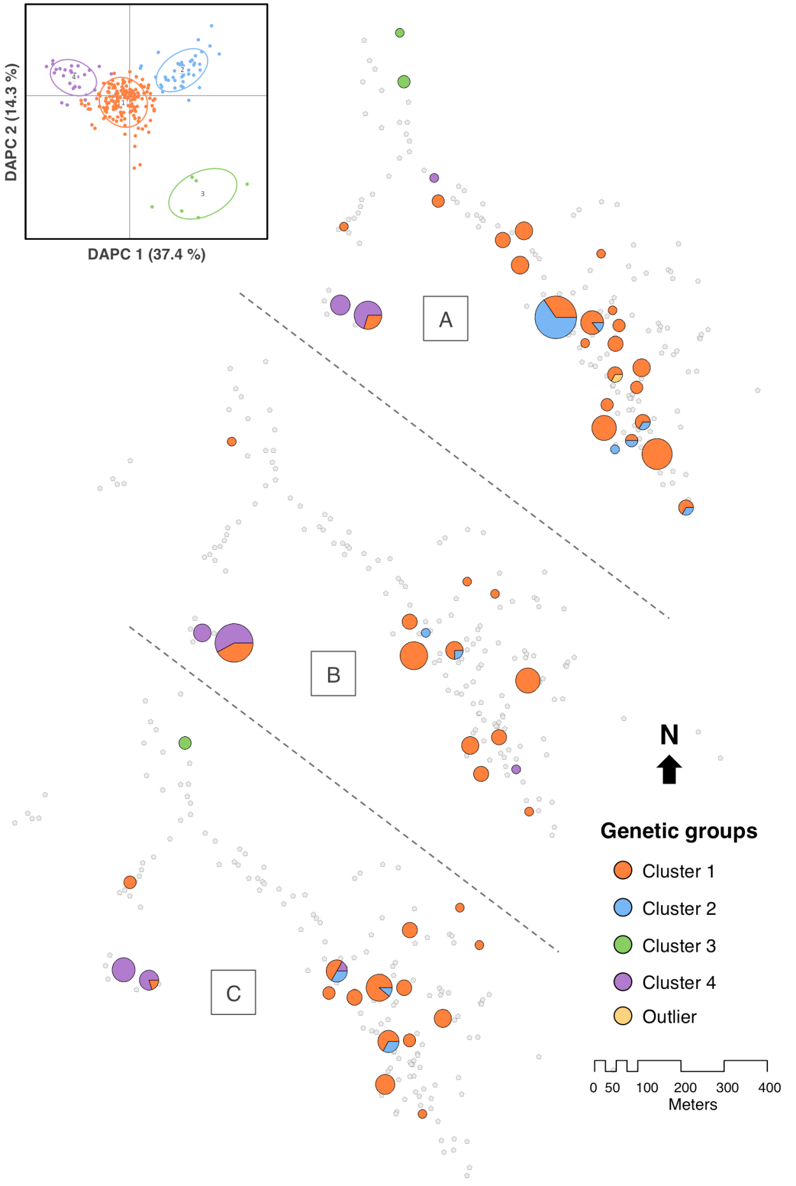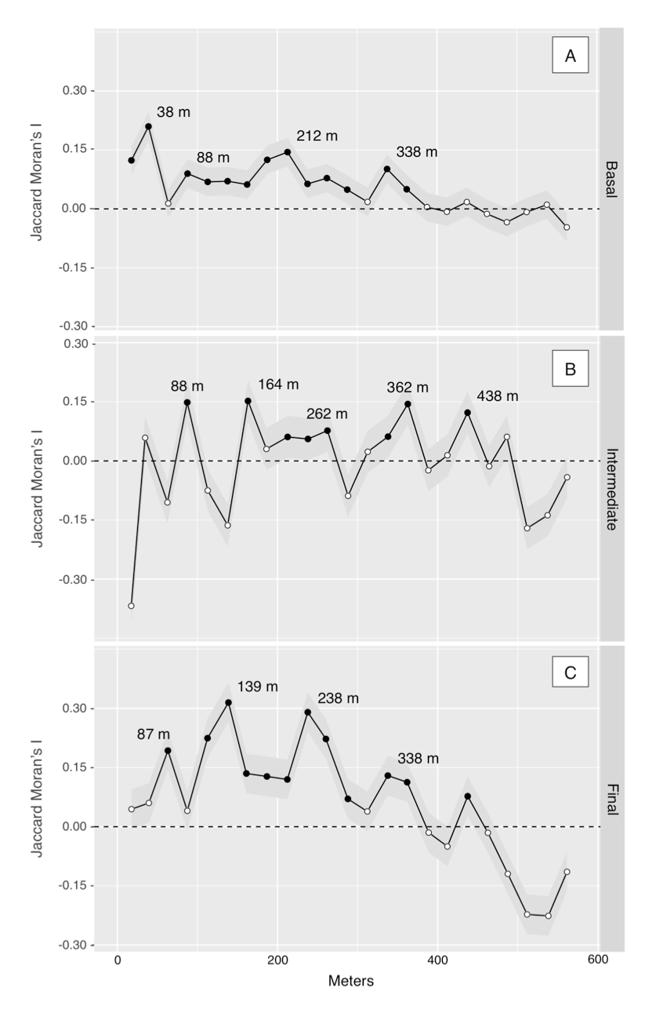

A.

B.

1

1

2

2

3

3

Fig. 3

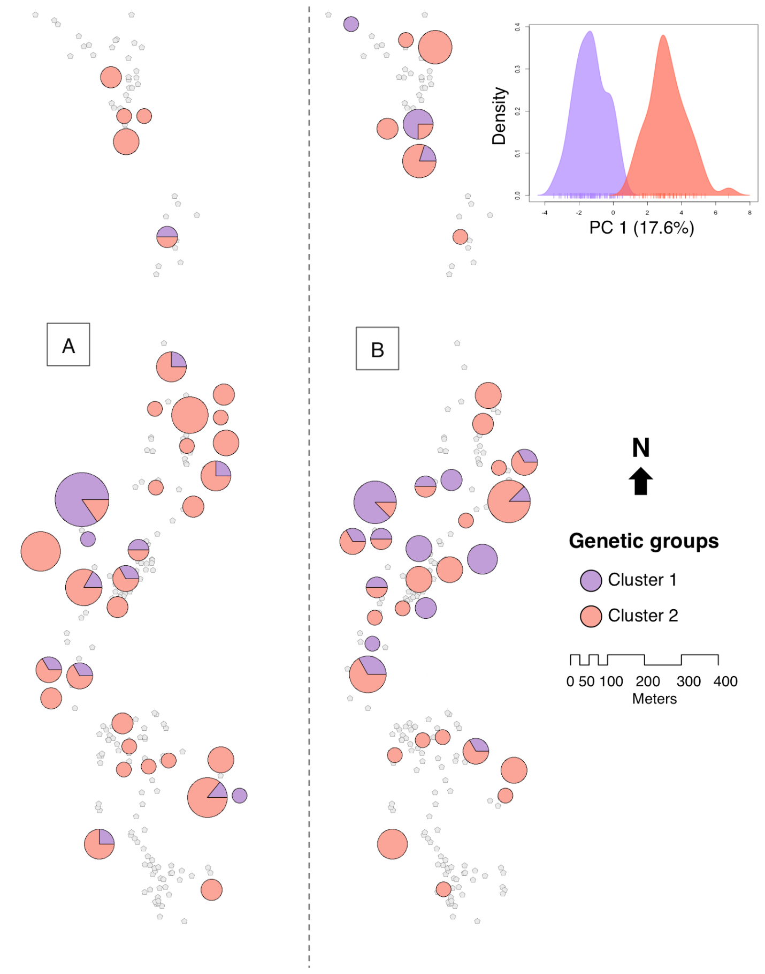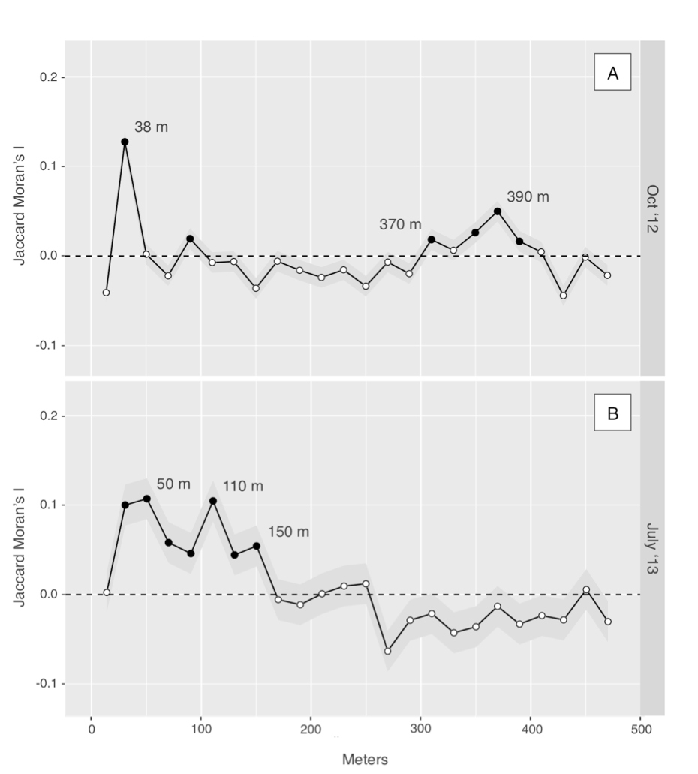

1

1

2

2

A.

B.

D-54

D-54

Fig. 4

Supplementary Figures

**Fig S1. Map of individual house locations in El Carrizal (A) and El Chaperno (B), Jutiapa, Guatemala.** Insert shows the location of the Department of Jutiapa in Guatemala. Source by ArcGIS 2009 (ESRI Inc., Redlands, CA).

**Fig S2. Spatial distribution of *T. dimidiata* infestation in El Carrizal.** Males (black), females (dark grey) and nymphs (light grey) were quantified across (A) the pre-spray survey in February 2013, (B) an early post-spray in January 2014, and (C) a final survey in April 2015. Symbols are sized in proportion to the total vector density observed.

**Fig S3. Spatial distribution of *T. dimidiata* infestation in El Chaperno.** Males (black), females (dark grey) and nymphs (light grey) were quantified during (A) prior to the dispersal season in Oct 2012 and (B) after the dispersal season in July 2013. Symbols are sized in proportion to the total vector density.

**Fig. S4. Comparison of observed and randomized distributions of nearest-relative distance following spraying.** The randomized curve represents the output of a single randomly-selected run (out of 999) from the random-assignment simulation. The mean distance from the observed distribution is significantly smaller than that expected from random dispersal (P < 0.001).

H:\Chapter3_Tables&Figures.17\Figure1.tiff

Fig. S1

H:\Chapter3_Tables&Figures.17\Figure2.tiff

Fig. S2

H:\Chapter3_Tables&Figures.17\Figure3.tiff

Fig. S3

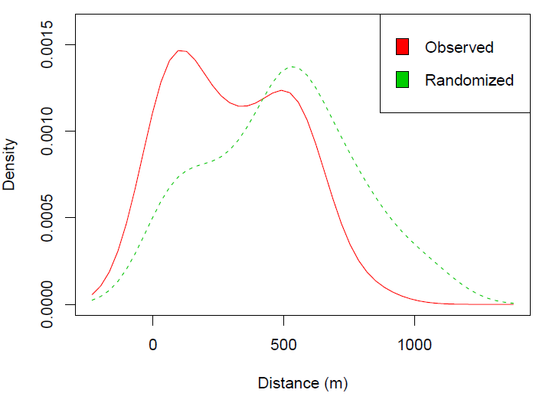

Fig. S4